**Sunkari Manohar**

**Python Assessment 2 – 14/12/2023**

**If Statement:**

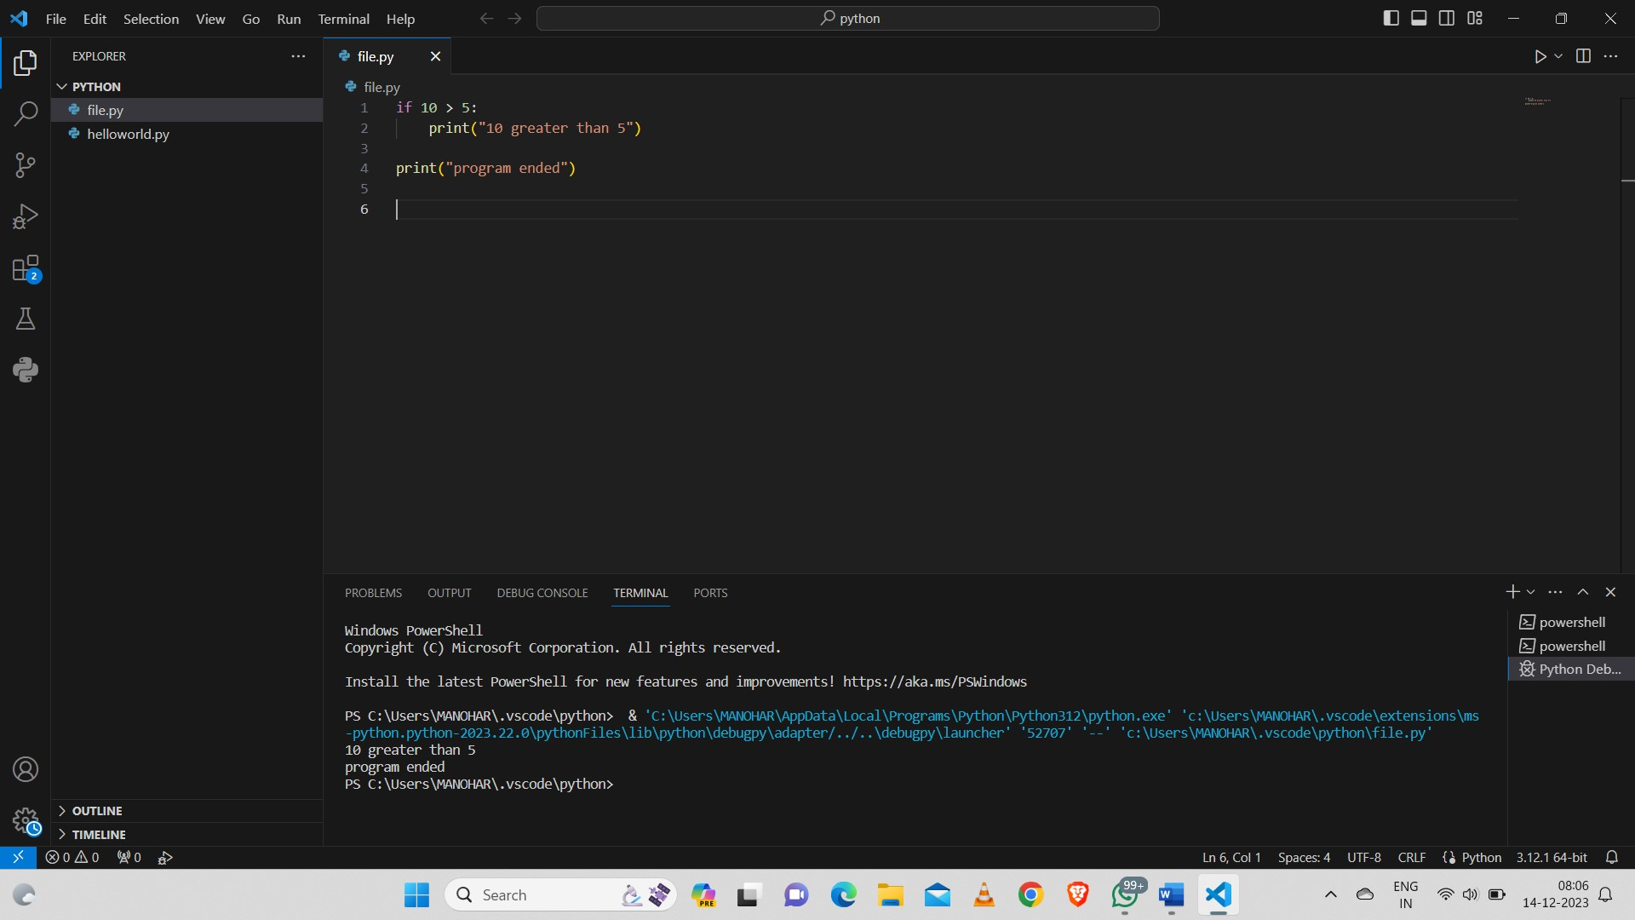

**If-Else Statement:**

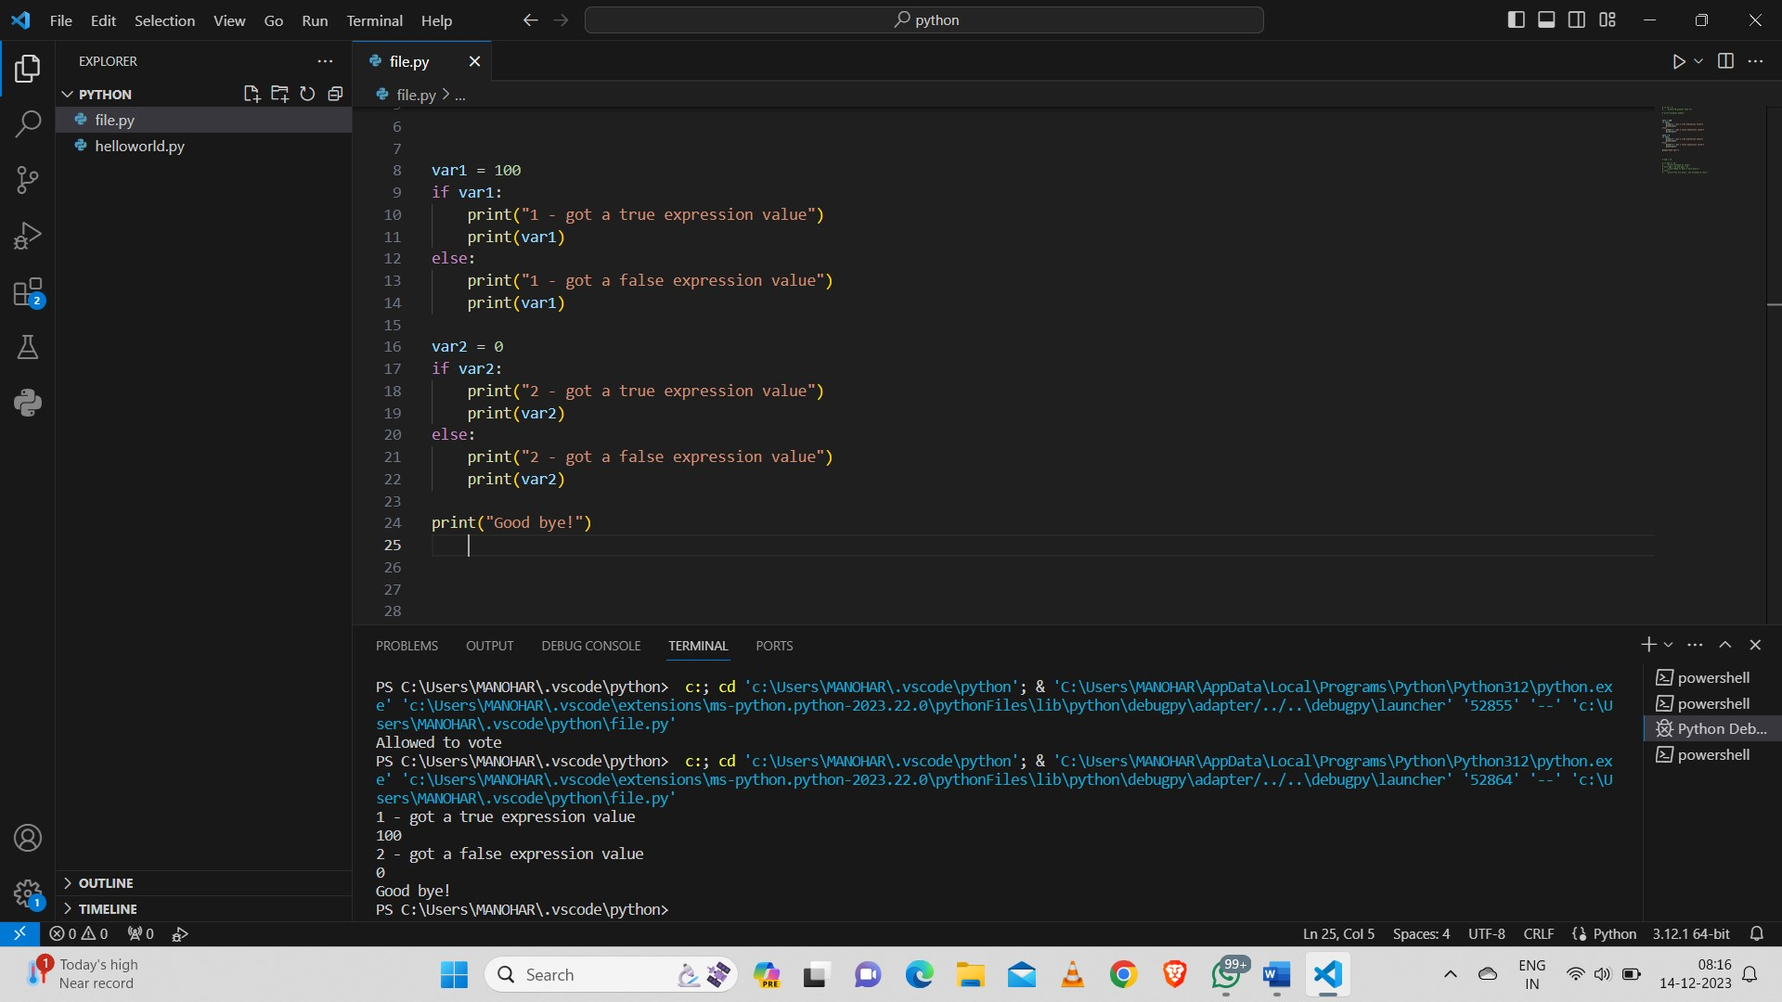

**If Elif Else Statement:**

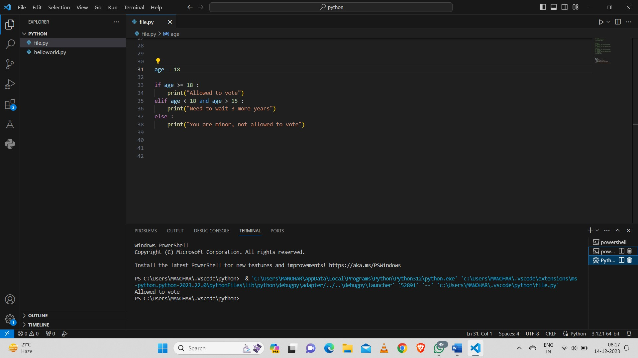

**Loops:**

**While Loop:**

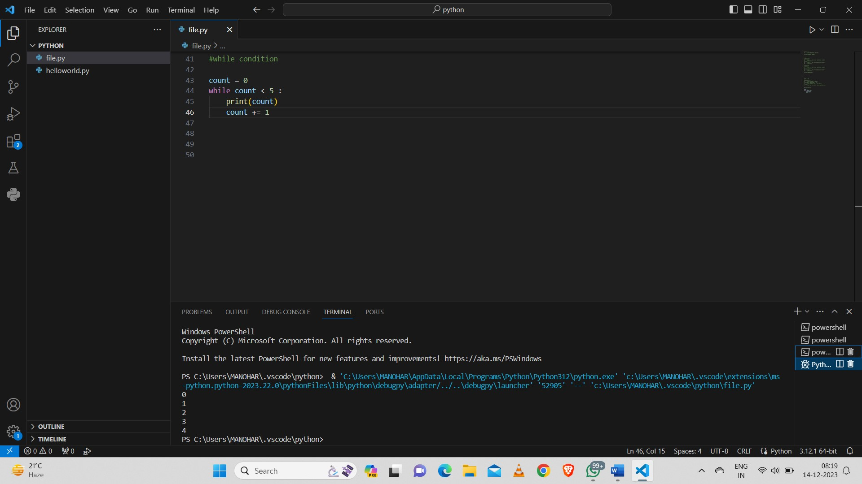

**For Loop:**

